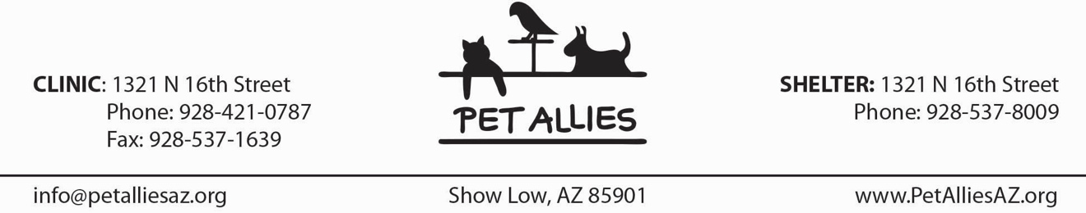

Minor VOLUNTEER APPLICATION
Note: Person described below is a minor.

NAME ________________________________________ DATE __________________________
(Last) (First)

STREET _____________________________________________________________________

CITY _________________________________ STATE ________ ZIP ___________________

E-MAIL ADDRESS _____________________________________________________________

HOME PHONE __________________________ CELL PHONE ________________________

EMERGENCY CONTACT Name & Phone ___________________________________________

* * * * * * * * * * * * * * * * * * * *
Liability Release & Waiver: I, the undersigned, understand that my participation with Pet Allies, Inc. is strictly on a volunteer basis. I understand that there are inherent risks associated with my volunteer activities, including the risk of personal injury resulting from animal bites and other animal behavior. I understand that Pet Allies is not responsible for any illness or injury caused by any animals that I come into contact with during my volunteer work. I agree to hold harmless and release from liability Pet Allies should I become sick or injured from any animals as a result of my volunteer work.

In exchange for Pet Allies’ agreement to allow me to participate in its volunteer program, I hereby release Pet Allies, including its officers, agents, employees and volunteers, from any and all claims of liability of any kind whatsoever, including but not limited to claims of negligence and/or injury to me arising out of my participation in Pet Allies’ volunteer program. I understand that by signing below I am waiving any and all claims of liability, including but not limited to claims of negligence and/or injury to me, against Pet Allies, its officers, agents, employees and volunteers, arising out of my participation in Pet Allies’ volunteer program.

Minor’s Signature _________________________________________________________

Date: __________________________________

RESPONSIBLE ADULT’S CONSENT:

Signature __________________________________________ gives consent

for _____________________________________________________ to volunteer at Pet Allies.
(Please Print Minor’s Name)

Revised 01/20/2024

