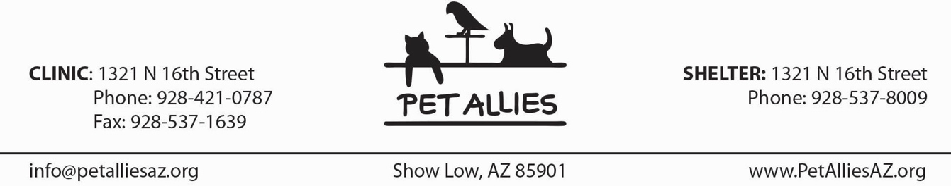

Adult VOLUNTEER APPLICATION

**MISSION: Provide non-lethal solutions to pet over-population**.

*SOLUTION: Furnish professional, affordable spay/neuter programs & place pets in caring homes.*

Pet Allies – Together We Are Altering Lives. Pet Allies encourages the participation of individuals who support our mission. Potential volunteers will be interviewed prior to placement. If you agree with our mission and are willing to be interviewed and trained, we encourage you to complete this application. The information on this form will help us find the most satisfying and appropriate job for you.

NAME DATE

(Last) (First)

STREET

CITY STATE ZIP

E-MAIL ADDRESS

HOME PHONE CELL PHONE

WORK PHONE (optional) BIRTHDAY (optional)

EMERGENCY CONTACT *Name & Phone*

*We’d like to get an idea of which volunteer positions interest you. Sometimes there are no openings for particular volunteer positions, and sometimes circumstances – such as the hours you are available – make certain volunteer positions impractical. Training will be provided for many volunteer opportunities, so don’t assume that you need to have experience.*

**Hands-on work with animals** *(training provided)*

Shelter Animals: walk dogs, groom/play with cats

Bottle feed orphaned kittens or puppies

Feral Cats: trap for neutering or advocate to solve problems

Adoption Counselor at adoption events

Foster Home for *(circle all that apply)*: cats, kittens, dogs, puppies, other small animals

For Office Use Only

Staff initials: ___________

*Pg 1 of 2*

**Phone work, paperwork, computer work, & other volunteer opportunities** *(training provided)*

Fundraising - Pet Allies conducts an annual fundraiser, the Rubber Duck Pluck, where many people are needed from the beginning of the year through the day of the event. Tasks can range from organization behind the scenes soliciting funds from local businesses to hands-on help. We also need someone who enjoys marketing and public relations which can include interacting with local chambers and community groups.

Clinic or Shelter - Clerical *(circle all that apply)*: e-mail and phone calls assisting clients with animal behavior or lost/found animal information, answer phones, write thank you notes, filing, office organization, create animal adoption flyers, distribute flyers promoting adoption & special events, shop for supplies (funds provided), and data entry.

Recovery at Clinic – which can include pre- and post- surgery care and client guidance.

**Do you have other skills or expertise to share?** Yes No If YES, please explain:

Do you have any physical or medical limitations which would limit the type of volunteer activities you can do, i.e., current health issue, back problems, etc.? Yes No If YES, please explain:

**\* * * * * * * * * * * * * * * * * * * \***

**Liability Release & Waiver:** I, the undersigned, understand that my participation with Pet Allies, Inc. is strictly on a volunteer basis. This may also include assisting in adoptions of pets through Pet Allies at Show Low Animal Control. I understand that there are inherent risks associated with my volunteer activities, including the risk of personal injury resulting from animal bites and other animal behavior. I understand that neither Pet Allies nor the City of Show Low is responsible for any illness or injury caused by any animal that I come into contact with during my volunteer work. I agree to hold harmless and release from liability Pet Allies and the City of Show Low should I become sick or injured from any animals as a result of my volunteer work.

In exchange for Pet Allies’ agreement to allow me to participate in its volunteer program, I hereby release Pet Allies, including its officers, agents, employees and volunteers, from any and all claims of liability of any kind whatsoever, including but not limited to claims of negligence and/or injury to me arising out of my participation in Pet Allies’ volunteer program. I understand that by signing below I am waiving any and all claims of liability, including but not limited to claims of negligence and/or injury to me, against Pet Allies, its officers, agents, employees and volunteers, arising out of my participation in Pet Allies’ volunteer program.

Signature

Date:

*Pg 2 of 2*

*Revised 1/20/2024*